REPORT
Bal Mela 2022

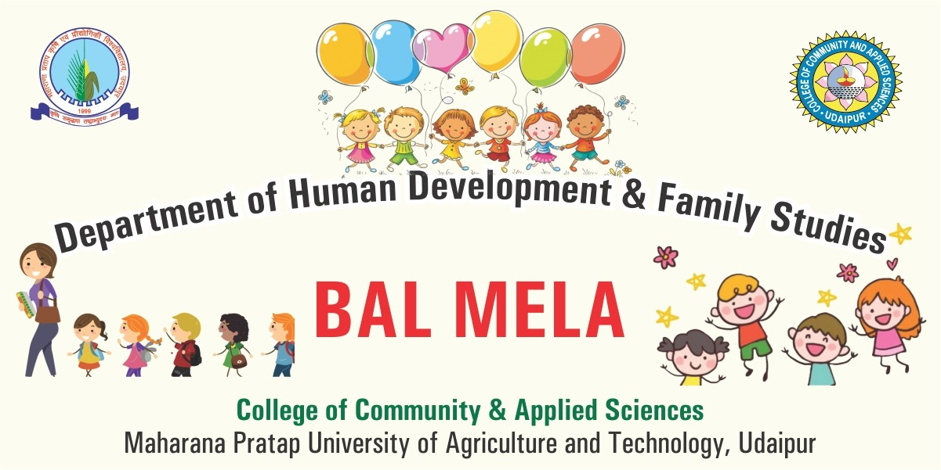
A Bal Mela was organized in the Lab Nursery school of HDFS department on 19th November 2022. At the onset Dean , Dr.Meenu Srivastava inaugurated the Mela, Head,Dept. of HDFS Prof.Suman Audichya, Administrative officer , Dr. Dhriti Solanki and all other Heads of the departments , students , Nursery school children & their parents were present. An array of stalls with a variety of mouth watering food items and exciting games were the main attraction of the Bal Mela. The Kids thoroughly enjoyed swings, merry go round, jungle gym slides and other play activities .Children took part in various games also. In the Mela music and dance corner was also included in which the tiny tots as well as college students participated with great enthusiasm. Such days of fun and enjoyment are aimed towards giving children a chance of enjoy their childhood and a great help in facilitating their overall development.
